|  |  |
| --- | --- |
| **Module:** | ST2053 |
| **Name:** | Marcus Prunty |
| **Student Number:** | 118730509 |
| **Chapter:** | 1 |

**Maximum 2 pages! Do not delete the page number in the footer.**

**a) Provide an appropriate scatter-plot for these data. Comment on this plot.**

The plot shows a strong linear relationship between Waist (X) and BMI (Y)

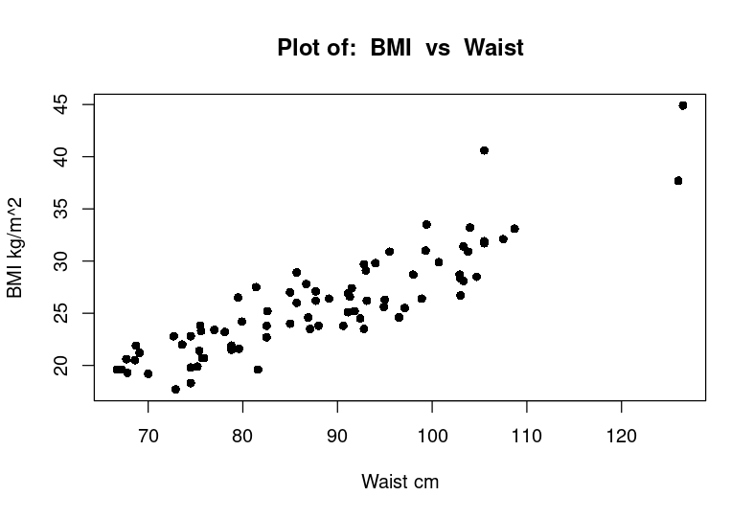

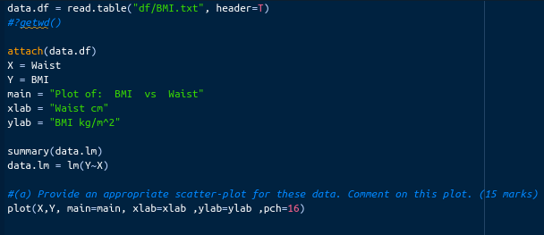

**b) Calculate a 95% confidence interval for the slope. Interpret this confidence interval.**

The calculated confidence interval = [ 0.3700, 0.2897]

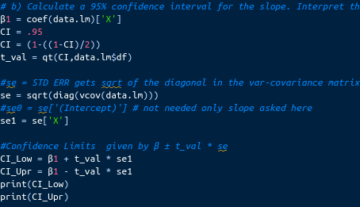The slope lies with 95% confidence within the given interval

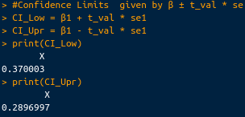

**c) Test the hypothesis H0 : β1 = 0.3 against H1 : β1 ≠ 0.3. Quote the value of the test statistic and the associated p-value.**

If |t| > t(0.025, 78), reject H0 . If p-value < 0.05, reject H0.

test statistic |t| = 1.48

t-value t(0.025, 78) = 1.9909.

p-value = 0.1429

Both test statements returned False, therefore fail to reject H0 : β1 = 0.3

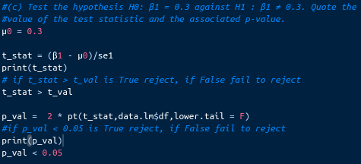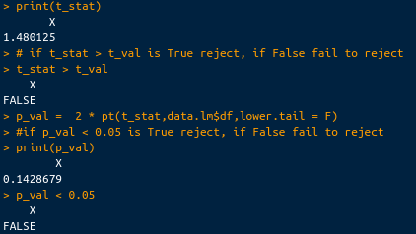

**d) Predict the BMI of an adult with a waist circumference 88cm. Interpret the associated 95% confidence interval.**

Predicted fitted value when Waist = 88cm the BMI = 25.8164 kg/m2.

With 95% confidence(default CI for predict function) the value will lie between [ 25.2885 , 26.3443]



